PESTEL model

* + 1. Political/Legal Factors:

<https://www.repubblica.it/green-and-blue/2020/12/23/news/che_fine_fanno_i_nostri_abiti_usati-279214965/>

* + 1. Economic Factors:

https://fluentconveyors.com/it/market/tessile-riciclaggio

* + 1. Sociocultural: Recycling culture is becoming more and more important (Circular economy)
    2. Technological: Higg Index (Toray Use Case), new web technologies allow traceability of clothes. Artificial Intelligence to understand which combinations might be the most liked by the clients
    3. Ecological:

<https://www.vestilanatura.it/moda-e-inquinamento/>

(EPRS_BRI)

Extending longevity of clothes

**Estimates show that if the number of times a garment is worn is doubled on average, the GHG emissions would be 44 % lower.** Several concepts have been developed in this direction:

• Slow fashion. Unlike fast fashion, slow fashion is an attempt to convince consumers to **buy fewer clothes of better quality and to keep them for longer.** The philosophy includes reliance on trusted supply chains, small-scale production, traditional crafting techniques, using local materials and trans-seasonal garments. It calls for a change in the economic model, towards selling fewer clothes. It is however not supposed to be

simply a marketing stunt to sell even more clothes. As a result it could threaten the economic survival of clothes producers unless consumers are also willing to pay higher prices.

• Fashion as a service. New business models could increase the number of wears of particular items by using the principles of the sharing economy. **Some brands already offer clothes as a service – leasing their clothes instead of selling them** – taking their example from already well-established services of renting wedding and special occasion wear, protective clothes and newer services of renting maternity and baby clothes. Other businesses operate clothes subscription services, where consumers pay a monthly fee to rent a fixed number of garments at a time, enabling them to change their wardrobe frequently without buying new clothes (this already works well with bags and high-end fashion, but increasingly also for everyday clothes).

• Improved collection for re-use, repair and up-cycling. Brands like Filippa K. are taking pioneering steps **by selling their used clothes in their regular shops to make buying second-hand clothes easier.** Others are offering long-term warranties that include offering free repair or replacement of a product, offering repair or instructions for repair, or offering upcycling or instructions for upcycling.

* 1. SWOT analysis
     1. Strength: Low cost raw materials, personalizable combinations of pieces from different brands, many different brands could be chosen as suppliers. Possibly unlimited geographical limits. The suppliers could ship the products to the final clients themselves using an intermediate posting system. To ensure a higher percentage of items are bought within a certain deadline, auctions starting at very low prices could be organized. The combinations could also be organized as surprise/joke gifts to friends in order to become more noticed on Social Media.
     2. Weakness: varying quantity of products (customers are not guaranteed to find the same product again), sizes of clothes might not be adequate, time of the year when the item is sold might not be the best, delivery costs might be higher than actual cost of the product. Large chains may decide to not join in.
     3. Opportunity: could allow clients to suggest combinations and show them to other clients (coupons or bonuses might be given away to best combinations), current political/environmental/sociocultural requirements
     4. Threats: companies might decide to not want their items to be sold at very low prices after a while
  2. BCG analysis (Problem Children)
     1. 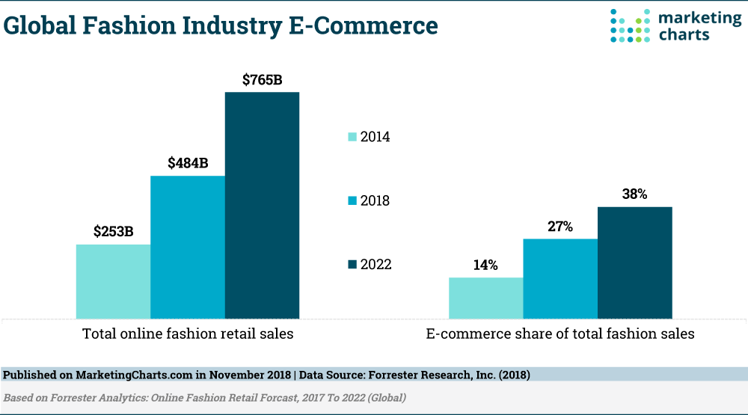High market growth
     2. Low relative market share
  3. Product Life Cycle

Type of New Product/Service: New to the world

This kind of 2nd life given to unsold products is certainly very innovative. It is different to what companies like Vinted propose because the products have not been used yet. Most probably the products have also not been damaged. Small apparel brands would get more publicity and could expand their market. Since the main audience is expected to be very young and searching for the latest trends

1. Porter’s Five Forces Model

New industry which will grow in the following years.

Threat of New Entrants: Customer switching cost is very low. Current online resale firms cover different parts of the global market and different types of products which range from luxury goods to secondhand items. Thrift shops or physical shops might not be much of a threat to a new online firm which in turn could be a threat to them. In Italy, Zalando is considered the main online retailer for clothes. Vinted is another website which offers peer to peer sales of secondhand clothes. They cover different types of customer segments and apparel compared to the one our application would deal with.

* + 1. Bargaining Power of Suppliers: variable. If large clothing chains are chosen as suppliers, they may have significant decisional power. If small stores are chosen, they have less decisional power. Therefore the target suppliers will most probably be small chains or shops that would prefer to prevent paying an amount of money to deal with unsold clothes and to instead receive at least a small amount for those items.
    2. Bargaining Power of Buyers: (B2C) probably low because typically the clothes will be sold at a lower price than in the original case. Also the “Complements” force will allow customers to appreciate the product more.
    3. Threat of Substitute Products or Services: Current Clothing industry may be not willing to allow a secondary market to develop. In particular, luxury clothing brands will not want to see their goods sold at much lower prices (e.g. Burberry and Cartier cases).
    4. Exit Barrier: possible warehouse and employee costs
    5. Complements: the sustainability of the products and origin. Products can also be personalized or designed by expert designers.
    6. Industry Competitive Structures:

Monopolistic Competition because there are a few new firms which however offer very different products. The entry barriers would not be too high because the potential market suppliers are many. The main aspects of the entry barrier are the warehouse costs.

FIRM EFFECTS

Entry Choices

* Entry timing: the Resale industry is at the beginning of its life cycle
* Focus on the customer’s motivation on why he/she decided to buy the object this way. Give him/her more details on how the purchase of the item helped reduce his/her environmental impact (es. Estimated Kg of CO2 saved, litres of water saved, …)

**Business Model**

**Who are the main stakeholders performing the activities?**

**What the business does to create value?**

It buys unsold products from other firms and gives them a new description/scope.

**Why does the business create value?**

The cost of the goods are low and general operational costs are low. Local shops may have a limited number of clients or may have limited visibility.

**How are the offerings to the customer created?**

Personalization of services/products using A.I. algorithms:

The firm uses A.I. algorithms to select target a larger number of customers that may want to buy the product and to perform combinations of different type of goods that can be sold together to make the overall package more attractive. The clients can also modify combinations of clothes presented to them and use chatbots and AI algorithms or talk to real designers to receive suggestions. The overall shopping experience can therefore be personalized and become more user friendly.

Experiential Marketing: Personalization of the online shopping experience is something new that not many other apps offer. A more enjoyable shopping experience can lead customers to ultimately become more attached to the service. Giving the possibility to consumers to also grade, comment or simply (dis)like existing combinations of clothes can contribute to making the app more interactive. Also suggesting new dressing attires could also be stimulating. Allowing users to simply pass the time by scrolling for new possibilities could also provide a nice opportunity for them to feel comfortable while interacting with the app. Since the items in the warehouses can change rapidly, this could be the opportunity to trigger the users’ attention when a combination that they could like is created. Users would also have the chance to appreciate the clothes more and to easily climb the “Ladder of Loyalty” from being a simple customer to a supporter/advocate.

**How should the company compete?**

**Cost Leadership**: low raw material cost. No need to change items. Faulty items may be bought from suppliers at a particularly low price.

The website also differentiates by offering good customer service and feelings when a new purchase is done, providing a high number of combinations of clothes from different brands.

**Nature of Business Model?** Bundling

The general idea to have very low costs allows us to also bundle together clothes to reduce the items left in the warehouse. To further reduce the leftover stock, frequent users can also be gifted simple items of their size which would be sent with the items they bought.

Branding

Our business model deals with pure goods delivered to young, environmentally conscious customers at a low price. Our brand therefore needs to evoke different values such as creativity, and ecology in which the final customers can identify themselves.

The Brand Name: **TCTG** (Too Cool To Go)

The brand name is an acronym because “Too Good To Go” is already a famous registered Danish app.



The green color of the logo symbolizes ecology and recycling. The “minimal” style of the characters conveys a sense of simplicity, friendliness. This logo would be shown to the customers only when opening the app or on the boxes in which they would receive the items they bought. The packaging would be made out of recycled cardboard and it would also have a very simple yet inviting look.

Within online apparel industry main **strategic groups**:

* Large online retailers which offer different kinds of products at low prices: Amazon, Zalando, ebay, AliExpress
* Secondhand retailers: Vinted, Wallapop
* Sustainable, Ethical online shops : Etsy, Good Apparel
* Online shops of large multinational chains: H&M, OVS, Macy’s, …
* Luxury Apparel Market Share Insights : Gucci, Giorgio Armani, Burberry (Due to strong brand loyalty, this market has high entry barrier to enter in this market)

Perceptual Map

The main competing brands we needed to take into consideration were the ones from Groups 1 and 4. We inserted our main competitors in the following perceptual map.

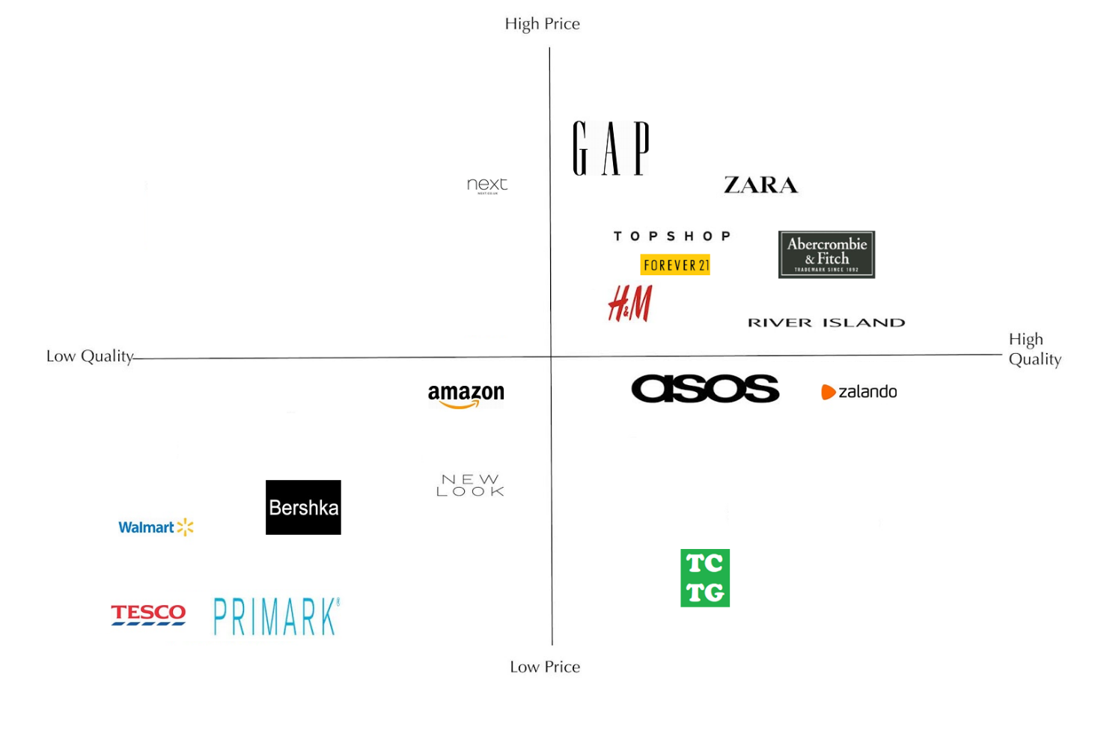

The Product Life Cycle

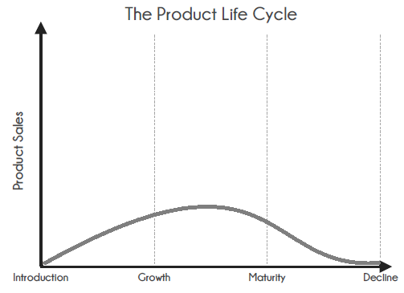Because the supplied products are at the end of their normal life cycle, the sales cannot be too high in any stage of their second life cycle. The quantity supplied may also be variable and this can cause the products to have their decline in sales earlier than usual.

Distribution

Our company would provide good quality items at a low price. An efficient distribution of the items would significantly contribute to decrease the overall prices. The best option in our case is also the simplest one: we would need to send the items directly to the final consumer using the national and international posting system. To decrease the general cost and environmental impact of shipping the goods from the supplier to a central warehouse to the final customer, using several small, dislocated warehouses could also be taken into consideration. This would also help to reduce the time needed to ship the items to the customer. The warehouse and shipping costs will be discussed more in detail later.

Segmentation, Targeting and Positioning

|  |  |
| --- | --- |
| **Variable** | **Properties** |
| **Profile** | |
| Age | 15-35 |
| Gender | Both Male and Female |
| Life cycle | Teens, young adults |
| Geographic | No particular geographical requirements. The area must be well connected to the postal system. |
| ACORN Targets | Categories C, D |
| **Psychographic** | |
| Lifestyle | Active, Adaptable, Economic |
| Personality | Conscientious |
| **Behavioral** | |
| Benefits sought | Convenience, Sustainability |
| Purchase occasions | Self-Buy |
| Purchase behavior | Not brand loyal |
| Usage | Occasional |
| Media Behaviour | Ads on Social Networks |

Customer Pen Portrait

Sara is a 23-year-old waitress working at a bar in the outskirts of Pisa near a small apartment she is renting. She is very open-minded and has an environmentally friendly mindset. She likes going to the gym and hanging out with her friends in her free time. She usually does not worry too much about wearing the trendiest clothes. Simple or sporty clothes are fine for her.

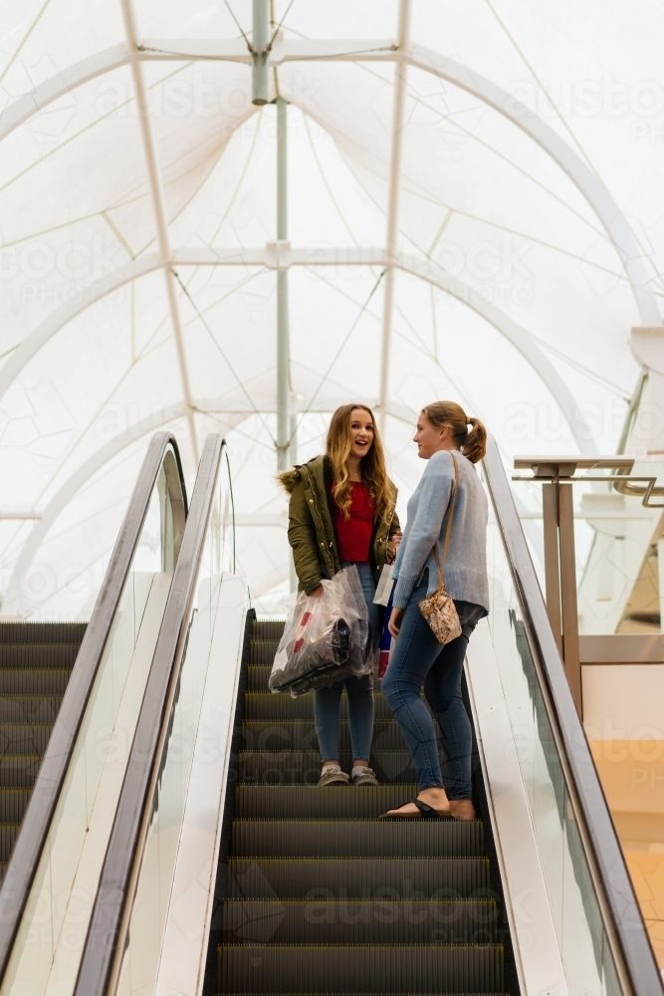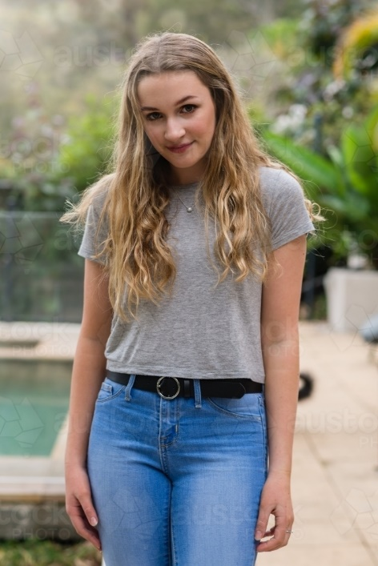

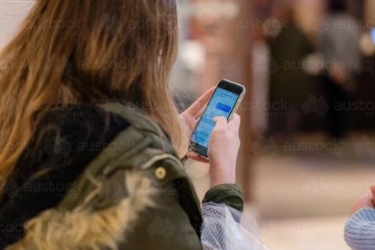

|  |  |
| --- | --- |
| Name | Sara |
| Age | 23 |
| Location | Outskirts of Pisa |
| Mentality | Friendly, Open minded, Environmentally aware |
| Ambition | Travel around the World |
| Daily activities | Work, Gym, Friends |
| Social media | Facebook, Instagram, Pinterest |
| ACORN category | D |
| Monthly income | €800 |
| Monthly spending on apparel | € 30-50 |
| Fashion style | Casual, Sporty |
| Preferred method of shopping | Online, enjoys shopping trips as well |
| Shops usually visited | OVS, sport apparel shops |